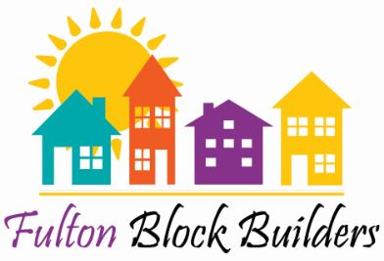

Fulton Block Builder
Administrative Director
Ph. (315) 529-9181 Email: fultonblockbuilders@gmail.com

What is the Paint Fulton?
Paint Fulton provides City of Fulton residents with a selection of historic color schemes to use for painting their homes. ANY HOMEOWNER in the city will be eligible for grant awards that use these historic colors. Homeowners can fill out a simple application, and if the project is completed by October 31st, will receive up to $1,000.00 (in matching funds) reimbursement check. Awardees will have a photo of their home featured on the Fulton Block Builders website and Facebook page.

Who is eligible?
1. Applying Block Challenge homeowners – add this application to the Final Application
2. One property per applicant. Applications are 1st come 1st serve and are due by April 29, 2024.
How do I apply?
3. Fill out and turn in this application by April 29, 2024 when you have decided to apply.
4. If your application is approved, paint your house using one of the historic color schemes provided on the Fulton Block Builders website. The entire house must be painted using the selected scheme.
5. Up to 50 possible combinations of colors are possible when using the 10 schemes (See how on the Fulton Block Builders Website) Property owners are also free to rearrange the recommended placements (body, trim accents) in any manner they choose. Only the colors within a single scheme can be used.
6. Property owners do not have to use all of the colors in a scheme, but must use at least two out of the 4 available (body, trim, accent, bonus colors).
7. Send in a digital photograph of the house before and after the finished work, and photocopies of all receipts for paint, supplies or contractor labor. Keep the original receipts.
8. Upon approval, a reimbursement check, for up to $1,000.00 in expenses (minus sales tax), will be issued within 6 weeks.

Questions:
Contact: Fulton Block Builders
Phone: (315) 529-9181 E-mail: fultonblockbuilders@gmail.com

PAINT FULTON APPLICATION

Please complete the following
Name: __________________________________________
Address: __________________________________________
__________________________________________
Phone: __________________________________________
Email: __________________________________________

Using the Paint Color Schemes on the Fulton Block Builders Website, please indicate the number that identifies the Scheme you intend to use:
Color Scheme # _________________________

When do you intend to start your project? _________________________________________
Will you provide receipts for reimbursement (Y/N) __________________________________
The amount you expect to be reimbursed for this project is: _____________________

Mail this application by April 29, 2024 to:
Fulton Block Builders
125 Broadway
Fulton New York 13069

If your application is awarded, you agree to allow Fulton Block Builders to document your group’s work, including your own project, and to use photos of your improvements on its Web site and Facebook page to publicize Paint Fulton

